IT Governance

# IT Governance Basics:

IT Governance is a subset of corporate governance focused on ensuring that an organization’s IT systems are aligned with its goals, deliver value, and operate securely.

# Preparation:

To prepare for an IT governance role as a fresh graduate, focus on these topics:

**IT Governance Basics:**

* **COBIT Framework:** Learn about COBIT (Control Objectives for Information and Related Technologies), a framework for IT governance and management.
* **ITIL Basics:** Understand the fundamentals of IT service management.
* **ISO Standards:** Familiarize yourself with ISO 27001 (information security management) and ISO 38500 (IT governance).

**Compliance and Audit:**

* Regulatory compliance standards (e.g., PCI DSS, GDPR, SOX).
* Basics of internal and external IT audits.

**Policies and Procedures:**

* How to draft and review IT policies and SOPs.
* Version control and document management techniques.

**Risk Management:**

* IT risk identification and mitigation strategies.
* Basic knowledge of enterprise risk management.

**Reporting and Documentation:**

* Practice creating clear and concise reports.
* Learn tools like MS Word, Excel, and PowerPoint for professional documentation.

**Recommended Certifications:**

* **CISA (Certified Information Systems Auditor):** Offers insights into auditing processes.
* **CISM (Certified Information Security Manager):** Focuses on security governance.

**General Skills:**

* Strong written communication skills for report writing.
* Collaboration tools like MS Teams, SharePoint, or Jira.

## COBIT Framework

**Control Objectives for Information and Related Technologies (COBIT)** is a globally recognized framework for IT governance and management.

COBIT helps to improve, implement and manage IT management.

It bridges the gap between Technical issues, business risks and control requirements.

COBIT was created by ISACA

COBIT 2019 structure is split into 4 components:

1. Introduction and methodology

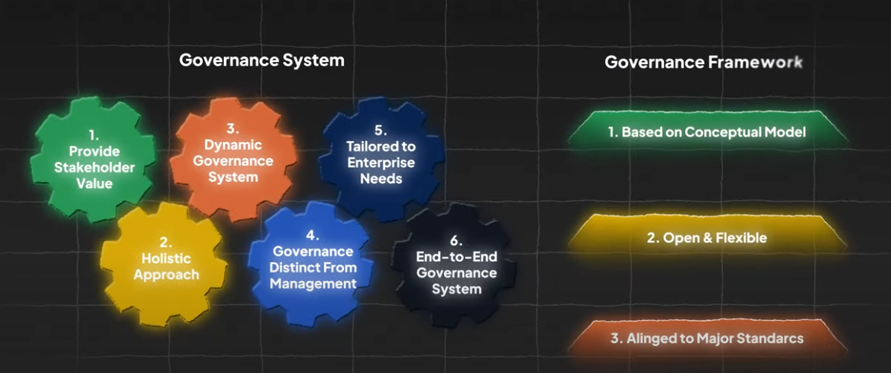

1. Governance and Management Objectives
   1. There are 40 of them.
2. Design Guide
3. Implementation Guide

Basic steps to implement COBIT:

